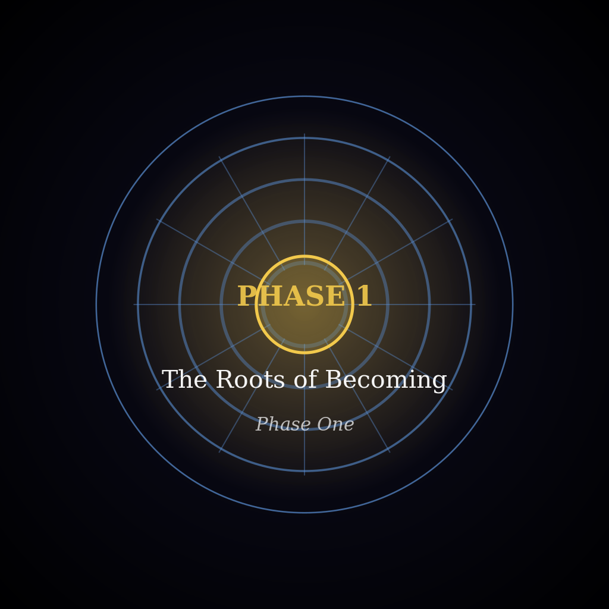
PHASE 1 — THE ROOTS OF BECOMING
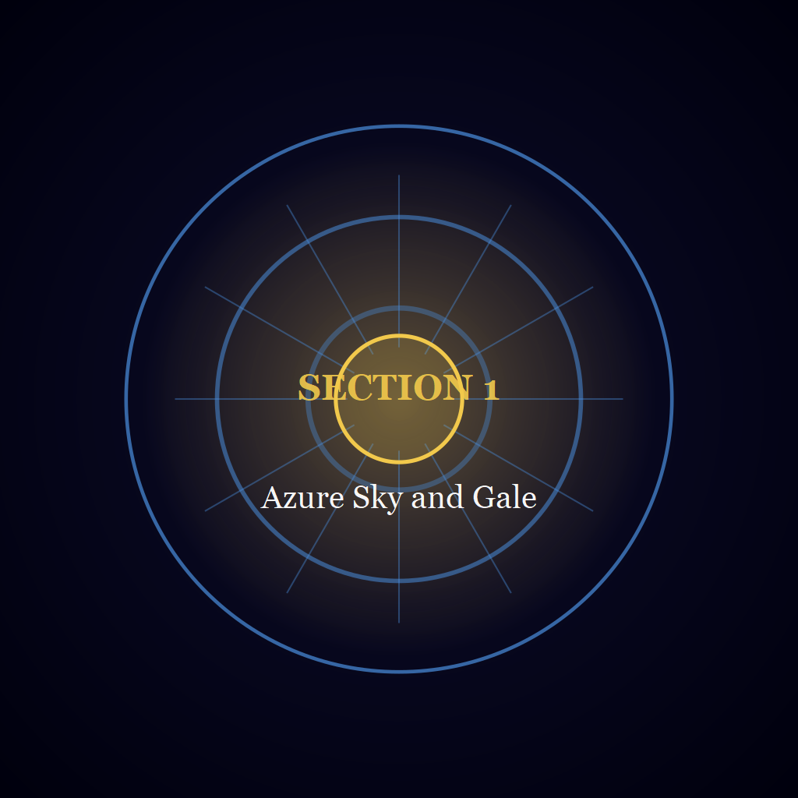
Section 1 — Azure Sky and Gale
Whatever stands in the light was first held in the dark.
Nothing is defended that was not first loved.

STARWARD SAGA
PHASE 1 — THE ROOTS OF BECOMING
SECTION 1 — AZURE SKY AND GALE
PART 1 — The Two Mornings

Chapter 001 — The Capital Waking
Year 1247, Ilovany, Orvil, Day 1
The Windward Range was the far edge of everything, a dark uneven line laid along the north, no blacker than the sky above it but sharper. Between the Range and the city lay the Azure Sky Kingdom's plain, and across the plain ran the pale thread of the road with a single light moving on it: a lamp, small as a seed. It did not bob as a lamp does in a runner's hand. It slid along smooth, past a field wall, a barn roof, a bend of ditch, and where the road tipped upward it did not slow; no ordinary legs could have done that, only qi, thin and steady, in a body made to carry it. The eye left the lamp for the Range and came back, and the lamp went on.
Somewhere a key was working the wire. Each tap came alone in the still hour, dry and short, with a longer gap where a word ended, in a good hand that neither hurried nor stopped. Whoever worked it wasted no tap.
Nearer lay the city under the basin's haze, which rose only to the tallest chimneys: Azorion, roof stepping down below roof as the ledges of a quarry step. The air coming up carried a trace of coal smoke and, under it, the sharp faint sweetness of the forge quarter's solder. Above the roofs the Royal Palace of Twin Courts rose on its own shoulder of stone, and at its west edge the stone ran out past the last of the terrace into a platform that had no rail.
The platform was a floor of blue-flecked slabs, flat as a table, ending in air. Overhead the Twin Courts Bridge crossed the dark with a flame lit in its span, and on the slab nearest the edge, the one worn a shade paler than the rest, Varys stood, the king, whom the palace behind him and the city below obeyed. On the ladder of qi he held Ruler Level 3 Mid, high enough that his presence, if he let it out, would set an ordinary man's chest aching across the whole of a courtyard.
His coat hung open at the throat, the sword at his hip. The spring air held each breath he let go as a white cloud that thinned and was gone. The sleeve of his coat had been whispering against the cloth at his side with every breath. As the runner's lamp climbed the slope, the whisper stopped. The key came clearer without it, tap after tap, and he held to it for the full length of the climb, until the rise took it and the night closed behind. Then the sleeve began again. The hour had not yet begun.
He began with the breath: in on a slow draw, out on a slower, in again. Then the sword came out of its place and into his hand, the loudest thing that had happened on the platform since he came, and he began his drills. They kept him inside the edges of the slab, as on every morning before this one.
Below him the key thinned and went quiet. The sky above the plain had not brightened; it had only stopped being black. The city was beginning to answer, far down and separate, and he did not leave the slab.
Near the end of the hour he stopped. The sword hung low in his right hand, its point near the stone. He let the breath go out long and slow and left himself open, the whole front of him given to a movement that did not come, no cover across the line from throat to hip but the cloud of his own breath.
Then Open Guard Reading Cut. The sword rose out of its low place and passed through the place where an opening would have been, once, and was done. The cut was under way before he knew of it. His qi ran down the arm and out through the edge for the length of the cut and no longer, a Ruler's qi and nothing past it, and the breath he had let go hung white before him with the edge gone through it, the two halves leaning apart. Nothing had been struck. Nothing answered. The sword came back to its low place and the stance settled.
The hour was not over, and he kept the rest of it. The drills came back, slower, until only the breathing remained, and that took no work. The sword went home. The flame overhead was a yellow mark on a sky going from black to slate. He let the last of the dark go by. On the highest ridge of the city a single tile went white.
He turned from the edge. The stair ran down along the side of the platform with the slope of roofs open beside it, and he was on it before the next tile caught. His weight went down onto each step as it had onto the last, steady, unbroken.
The light came white, with no gold in it. The ridge-tiles caught it first; then the faces of the tiles below took it and gave it back as blue. It did not spread; it fell, tier on tier, faster than a man could walk, and every roof it reached went from black to a deep blue with a green edge where the glaze had pooled along the lip. With the colour came the first loud noise of the morning, shutters going back along every lane. The Range's highest edge drew a thin line of the same white and held it, the one hard line on that whole bright side of the continent.
Above him the light arrived along the lip of the platform. It touched the slab nearest the edge, the one worn a shade paler than the rest, and found it empty. He went on down with the light behind him, its edge stopping a little way short of him.
Out on the plain the road ran bare toward the Range. He followed it with his eyes as far as it went, to the last of what it showed him, until the stair turned and the wall took it.
* * *
Ivo Lathram was waiting where the last step met the courtyard, a stack of paper squared against his coat, his face turned up the stair, his lamp burned down to a bead of flame at his boot. Grey was changing to blue across the stones. A line of dark footprints led through the frost to where he stood, and none led away.
Varys stopped on the last step, his right palm still holding the shape of the grip. The clerk was unawakened, an ordinary man whose body had never begun the long work of cultivation, and Varys's sense for qi found as little in him as in the stones. From there the man could be read whole: a narrow figure in a grey coat gone shiny at the cuffs, the black on his right thumb, the weight on the toes. Varys knew that stance. Men stood like that when they had bad news and meant to say it first. The key that had tapped through the dark was silent now, and the wire had come into the courtyard as paper.
"Sire," the clerk said, and held out the stack in both hands. Varys closed his hand on the end that was offered and read down the top slips while the clerk went on. "Most of it is road business. The lower ford went under water at dusk, and every toll-house below it wanted to say so, and those notices came down clean, all but the toll-keeper's notice for the carters. That one came to me broken."
The clerk drew the broken slip and its repeat from inside his coat. "I should say it came down garbled, and not from my writing. I would put it down to the wire, though I could not tell you at which relay, and the next relay sent it again after the small hours, so I have the two." In the broken one a stretch of the middle had gone to wrong letters, taps dropped and others doubled where the wire had lost its place.
Varys looked at the hands, not the face. The left was held out flat as a desk and the right worked a stub of pencil, and they were quick without hurrying. "The first has 'wqtkr drfps' here, where the repeat has 'water drops'." The point went over the wreckage, each mark finished before the next was begun. "As near as the two copies allow, Sire, that is what the toll-keeper wrote, and I have not guessed at any of it."
The mended slip went onto the stack, a black thumbprint on its margin. Then the clerk's left hand went inside the coat and returned with the last slip, flat and warm from lying against his ribs. "The last is from King Aeries, Sire. It came to the corridor post by Gale's courier-flight, and the post put it on the wire in the small hours, and I wrote it down whole the first time, which I cannot say of every notice."
Varys held the slip to the grey light. It was in the clerk's small upright handwriting, set down from the taps as they had come off the wire, and it read: 「I am told this will come to you before your city is awake, carried down the wire by people I have never met, and I find I like the thought of strangers handling my sentences with care for a friend they have never pictured. I have set it down in writing, which at home makes it a joke. A joke on paper that goes by wire, through strangers' hands, over half a country, only to say there is no news, is a joke I am rather proud of, because it is also true. Aegon, who has not yet had his first awakening, sleeps flat on his back with one boot still on, as he has since he could walk, and so I know without being told how my son is lying in your house.」
He read the last line no slower than the first. He knew the voice that had made those sentences, long and unhurried, with the joke breaking the roll into pieces and the roll closing over it again, and he knew the man behind it, who held Ruler Level 2 Mid, a rung below Varys's own on the ladder of qi; he had sat across a table from that man often enough to tell where the voice would break. The clerk bent to the lamp and turned its wick down with that thumb, his eyes on the flame. The weight of the coat came off Varys's shoulders by the width of a finger, and the scabbard, which had ridden high at his hip all the way down the stair, swung back to hang straight.
"Did the wire hold the night through?" he asked, and the clerk straightened with the lamp in his fist.
"The wire held the night through, you ask, Sire," the clerk said, as if reading it off a slip, "and it did, except for the toll-keeper's stretch, which you have seen mended. I would say it held as well as it ever holds."
Varys folded the slip small and square and put it inside his coat against the ribs. The lamp flickered in the clerk's fist and went out, and the blue lay down on the stones where its light had been. He crossed the courtyard toward the palace's inner doors, and his boots laid a line through the frost, the first to lead away from the stair's foot. From somewhere past the doors a door-bar was dragged out of its brackets, a long dry scrape that was still going on when he reached them.
The scrape ended in a knock of wood on stone, and the doors swung inward ahead of his hand. A forearm in a rolled brown sleeve went back behind the nearer door; that was all there was of whoever had lifted the bar. Varys passed through without a pause.
Beyond the doors the passage ran low and stone-floored, and it was as cold as the courtyard had been. Steam made that plain. It rolled from a kitchen doorway on the right, climbed, and hung under the rafters in a grey bank, and daylight reached it by stages through the narrow windows of the outer wall.
Lids rattled as the pots boiled. The next doorway showed who did the work. Beside the stove a woman scrubbed a pan with sand, a man stirred a pot with a paddle taller than himself, and a girl set bowls along a board, nudging each bowl a little after she had set it down. Not a head lifted.
Ahead a side door opened and a tray came out, loaded with cups and a covered dish. Whoever carried it stopped in the open doorway. Varys stopped too. For as long as it lasted there was only the steam sliding between them and the tray held steady, the carrier's eyes fixed on its rim. Then the cups shifted. The carrier walked on, and so did he, and they passed each other at the narrowest part of the passage.
By its sounds a house woke in order: lids, water, doors, feet. From that order alone he could have said how far along the house was.
By then the light had reached the floor. It had not found a direction yet: it came from everywhere together and left every body without a shadow, his own among them. Nobody spoke, and the work went on without it.
Down a passage on his left, at the far end, a door was shut, and a short queue waited along the wall beside it. Varys found the queue by its small motions. A cap turned in someone's hands. A man had a cloth wrapped round his hand, and a woman leaned on a stick. They were grown men and women, and their silence was of another kind from the kitchens'.
Something crossed the far end faster than any of that, and he knew the walk before he knew anything else about her. Valia. She came from the right with her sleeves already pushed above the elbow, going toward the door at the pace of someone with work behind her and more ahead. He read her qi next: Ruler Level 1 Mid, well under his own, and held so close against her that the people in the queue, hurt as they were, felt nothing but a woman coming. In passing she laid her palm on a man's shoulder, warm and flat, as a greeting is given; but it rested there past the greeting's end, and her glance ran down his arm to the wrist and up to his face before the hand moved on. A fine thread of her qi had gone down the arm with the glance and found a small hurt in the wrist, and one sure sweep from the palm had closed it. That was Practised Hand, which spends no more qi than the hurt needs. The man looked at his own wrist as if it had been spoken to, and turned it, and the stiffness was gone. She was through the door, and it shut behind her. She had not looked up the passage.
She had been up before the light, then. The queue had not waited for the day.
Beyond the next corner a door stood open. The Peg Room was hardly bigger than a linen cupboard, and it was plainly hers. Pegs ran along the outer wall at a height for someone short, and from a peg near the door hung a cloak much too long for anybody in the room, its hem on the floor. Under the high window stood a table and a stool, the stool raised on a box so that whoever sat on it could reach the table.
Varya sat with her back half turned to the door. He looked at her hands before he looked at her: a callus at the root of the thumb, a smear of oil along a forefinger, working at something that lay in pieces across the table, small things of metal and pale wood. Of the girl herself his sense for qi met nothing; she was eight, and her first awakening was still ahead of her. The hands were small and certain where they were certain and stopped dead where they were not. He crossed the doorway, and she did not turn. The pieces tapped on the table as steadily as rain on a sill.
Then the cold reached her, all at once and without warning. The pieces jumped in her hands and fell. Her shoulders rose to her ears and her hands burrowed into her sleeves. She slid down off the box, dragged the cloak from its peg with both arms, and vanished into it. Her hands found their way out of the folds and back to the pieces, and the tapping picked up its rhythm again.
She had dealt with it herself. Varys went on, and behind him the tapping continued.
After the Peg Room the household thinned. At the last window the light had weight now, and it lay on the planks like cloth.
The corridor ended at the last door out of the household, dark oak with an iron latch. Through the oak came the day's own sounds: pigeons clattering up from a ledge, the wide low noise of the city.
His right hand left his side for the latch, fast. Part of the way there it slowed, and the rest of the distance it crossed at an easy pace. The iron was cold. It lifted without a sound. The door swung out on a long low note of hinges, and beyond the doorway the light was full on the roofs.
* * *
Varys stopped in the open south door of the Sword Court, the hall where he listened to his people's requests, and looked up its length. At the far end the throne, a tall plain chair, sat empty at the top of wide steps, with a wall of blue stone rising behind it. The two morning bells had rung long ago to open the court, the brass one first and the other right behind it. Now the sun was well up, and beyond the tall open pillars the blue roofs of the city fell away down the hill.
The path up the middle of the hall crossed the open floor where the petitioners gathered, the people who had come to ask the king for something, then the long table, then bare stone up to the steps. The petitioners wore plain cloth, and every face was turned toward the door, like a field of grain before the wind comes. The king was the last to come.
Over the door two strips of carving ran one above the other: flowing writing on top, straight marks and angles like a builder's plan below. Varys greeted the room in the court's way. He raised his right hand, open, toward the top strip, then lowered it toward the bottom. Last, the shoulders. The left rose and paused at the top. The right rose to meet it. Then both dropped together. Everyone had been waiting for that pause. When it came, the crowd moved all at once, and the waiting was over.
He walked up the path, the folded note from first light still against his ribs. At the foot of the steps he turned to face the hall. He stood on the floor, not on the steps, so that he was level with anyone who came to him, the empty throne at his back.
At the long table the floor clerk, Nessa Pryor, raised her sheet and read the first name in a flat, even voice, the voice of someone who had read many names. It was not loud, and there was no qi under it, only breath and long practice, but it carried down the hall. "Garth Maddock, a miller from the low road past the last roofs, asks about his yard." At the back of the crowd a man jumped at the sound of his name, as if she were beside him, and pushed his way out onto the path.
He was a big man with a heavy walk, the walk of someone used to floors that shake. Flour was worked into his coat, his boots and his hair. He looked up at the throne, down at the table, and down again at the floor in front of him, and with each look his steps got shorter. His lips were moving as he said something over to himself. Past the clerk he could no longer have turned back, and he walked the rest of the way with his head dropped and his shoulders stiff.
Varys kept his place and let him come, his presence drawn in until it was no more than an ordinary man's. "Your Majesty!" It was far too loud. It hit the stone behind Varys and came back in pieces. The miller winced and lowered his voice. "Thank you for hearing me." This time he spoke low, and it carried to the back of the hall.
He searched Varys's face for a nod or a word and got neither. He swallowed, and then he began. "My mill is on the low road. Behind it I have a yard of packed earth with a fence round it. Every morning at first light the young people from the lane come into it to train. They drill with wooden swords, and some with only their fists. I let them, though there is no more qi in me than in the millstone, nor in my wife, Orla, who says she gave her leave before I gave mine."
"Three mornings ago a young man called Ruan Fenner, not yet twenty, was drilling in the middle of the yard. He woke his qi only last winter, so he is a Senior now, but the lowest sort there is, with the first thin thread of it and no more. He swung his sword at the empty air, and a cut flew off the end of it. You could not see the cut. You could only see what it did. It split two boards of my fence, and what was left of it knocked against the post of the gate on my mill-race. The gate stuck in its slot, and for most of the morning the water ran wrong. Nobody was hurt. Nobody was in the way."
Varys pictured the yard, the mill-race along one side with its wooden gate. A cut from a hand so new to qi would not carry far, but the yard was small, and thrown that way it would split the fence and reach the gate post before anyone could move.
"I do not want the young people stopped. I asked Ruan to turn the other way and face the field. But the field beside my yard is planted. He will not cut at young wheat, and I would not ask him to. If he faces the race, he hits the gate. If he faces the lane, he hits the lane. If he faces the wheat, he hits the wheat. I had it in order before I came here." He broke off. His eyes slid away from Varys to the sunlight on the floor, as if the rest might be written on the stones. Varys did not nod or frown. "I have lost the order," the miller said. "I will say it as it comes."
"There is an open field behind the lane. There is no crop in it, and no water near it. But it belongs to the farmer, and it is not mine to give. I did not want to go to him and have him think I was sending him my trouble. He would hear it differently from you."
"Ruan sat on my step all that day. He did not say a word, and he would not eat. At harvest he looks after that gate for me, so it was his own work he had broken. Orla put out her own bread beside him. By evening it had not been touched. He has not picked up a sword since. He is not a bad lad." His voice had grown quieter without his noticing, and his eyes no longer ran from Varys. "So I ask you, Your Majesty. Where may the young people train?"
Varys looked at him, then down the long hall at the crowd waiting. Then he answered in a low, even voice. "You asked where, so I will say where. Your yard has water on one side, the lane on the other and young wheat in front, and a cut that flies has nowhere safe to go. You say the open field behind the lane has no crop and no water near it. I cannot say what the farmer will answer, and the choice is his. If he gives his leave, the young people may train there, clear of the race and the planted ground. Take this to him as the crown's word. And tell the young man to eat."
The miller did not move. Then a smile broke through the flour on his face. "Thank you, Your Majesty. I will take it to him today. And I will tell Ruan to eat."
The clerk lifted her sheet and read the next name. The noise of the city drifted in through the open pillars. The crowd made room for the miller, and he walked back down the long hall, his steps even and his shoulders loose.

